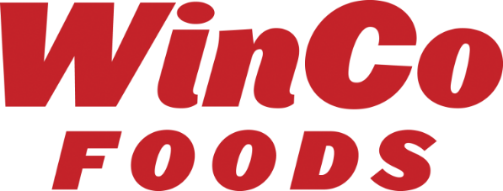

December 23, 2020

Dear Valued Vendor Partner,

WinCo Foods, LLC is pleased to announce the Grand Opening of our new store in Missoula, MT on February 22, 2021.

Store #165 Missoula, MT
2510 S Reserve St
Missoula, MT 59801

Please begin EDI set-up of this location in your system if you participate in our direct truck programs. DUNS information is located on our vendor portal. http://partners.wincofoods.com/

We are looking for aggressive deals to support our Grand Opening. All deals should have order dates beginning in January to support the store fill and continue to March to allow for replenishment as needed during the first month of sales. Please reach out to your Procurement Contact:

Kyle Puckett – Grocery (Non-Temp)
Brian Oberlander –Non-Edible Grocery, Refrigerated / Frozen Grocery
Susan Barry – Private Brands

As always, WinCo Foods LLC is grateful to have you as a partner and appreciates your support!

Looking forward to growing together,

Kathy Miller
VP of Procurement
WinCo Foods, LLC

