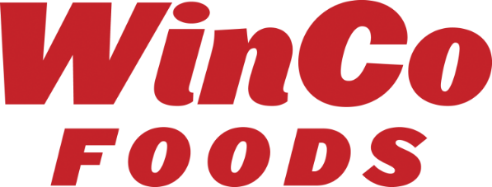

June 20, 2022

Dear Valued Vendor Partner,

WinCo Foods, LLC is pleased to announce the Grand Opening of our new store in Silverdale, WA on August 22, 2022.

Store #169 Silverdale
10315 Silverdale Way NW
Silverdale, WA 98383-7691

In anticipation of this Grand Opening, the DSD Buyers of the following categories will begin accepting “New Store Opening” offers. All offers must be completed no later than July 15, 2022. Please contact your appropriate DSD Buyer located at the Corporate Office in Boise, ID to submit offers during this time frame.

- DSD Beer, Wine and Spirits – Kristin Hodgson
- DSD CSD and Non Alcoholic Beverage – Maxine Jones
- DSD Bakery and Salty Snacks – Bill Porter
- DSD Cookies and Crackers – Bill Porter
- DSD Frozen Foods – Shawn Frederick
- DSD Dairy and Eggs – Shawn Frederick
- DSD General Grocery / Variety – rpvendors@wincofoods.com

The current forms that you will need to make your presentation is located on our Vendor Portal at http://partners.wincofoods.com/DSD. Please make sure you include the following:

- Promotions Offers available in August & September
- All set & fill load deliveries must be at Promotional pricing. Make sure your promotion dates coincide
- Special Offers for Grand Opening – make sure your promotion dates coincide
- 2 Case Free Goods –WinCo New Store Distribution Allowance program

If you would like to participate in any In-Store Advertisement, Digital Options, Coupon Give Away or In-Store Demo, please reach out to WinCo Foods advertisement team prior to Grand Opening. As always, WinCo Foods LLC is grateful to have you as a partner and appreciates your support!

Looking forward to growing together,

Kathy Miller
VP of Procurement
WinCo Foods, LLC

