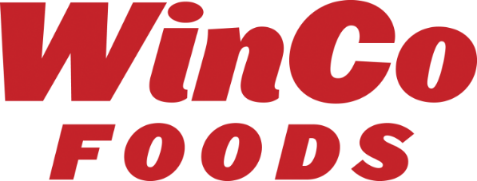

June 20, 2022

Dear Valued Vendor Partner,

WinCo Foods, LLC is pleased to announce the Grand Opening of our new store in Silverdale, WA on August 22, 2022.

Store #169 Silverdale
10315 Silverdale Way NW
Silverdale, WA 98383-7691

Please begin EDI set-up of this location in your system if you participate in our direct truck programs. DUNS information is located on our vendor portal. http://partners.wincofoods.com/EDI

We are looking for aggressive deals to support our Grand Opening. All deals should have order dates beginning in July to support the store fill and continue thru September to allow for replenishment as needed during the first month of sales. Please reach out to your Procurement Contact:

Kyle Puckett – Grocery (Non-Temp)
Brian Oberlander –Non-Edible Grocery, Refrigerated / Frozen Grocery
Susan Barry – Private Brands

If you would like to participate in any In-Store Advertisement, Digital Options, Coupon Give Away or In-Store Demo, please reach out to WinCo Foods advertisement team prior to Grand Opening. As always, WinCo Foods LLC is grateful to have you as a partner and appreciates your support!

Looking forward to growing together,

Kathy Miller
VP of Procurement
WinCo Foods, LLC

